**GIT Branching**

Name – Aniket Narale

Section – C

Objective: Commit HTML, CSS & JavaScript assignments into GIT.

1. Create a new branch ‘js-assignments’.



1. Switch to ‘js-assignments’ branch.

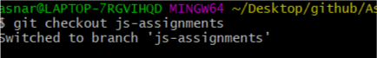

1. Copy all JavaScript assignments inside ‘Assignments’ folder.

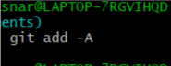

1. Commit JavaScript assignments into ‘js-assignments’ branch.

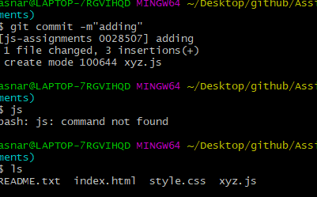

1. Make minor changes into README.txt file on line 1 belonging to ‘js-assignments’ branch.

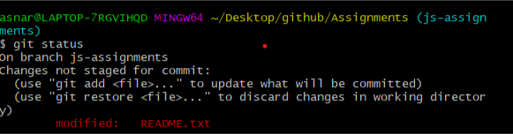

1. Commit those changed files.

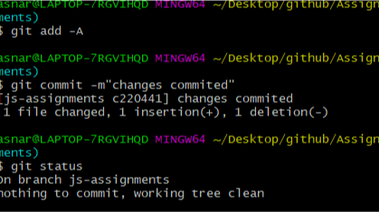

1. Switch to master branch

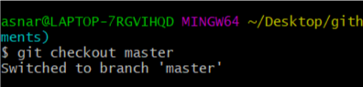

8. Make minor changes into README.txt file on line 1 & commit those changes into

master.

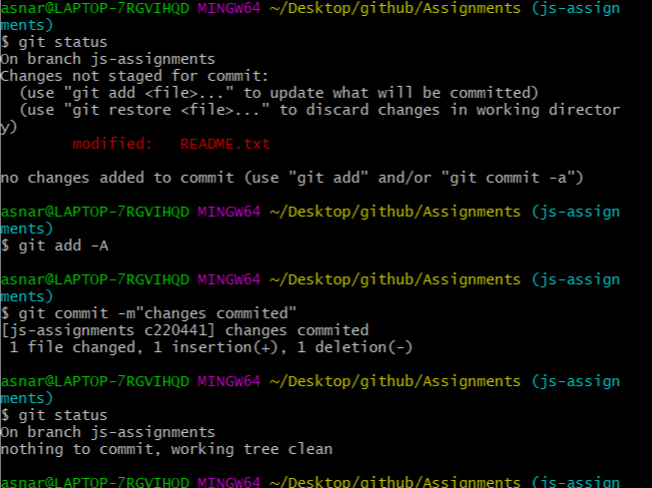

1. Again switch to ‘js-assignments’ branch.

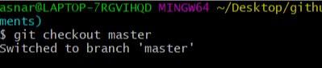

1. Make minor changes into few files belonging to ‘js-assignments’ branch.

10.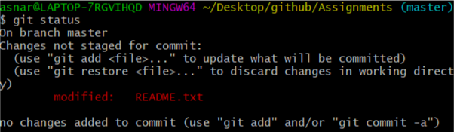

11Commit those changes.

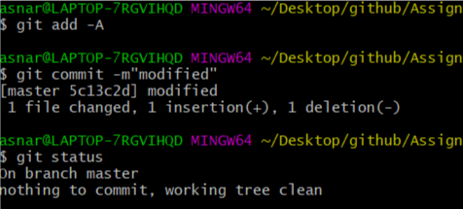

1. Switch to master.

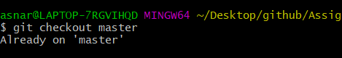

13. Merge ‘js-assignments’ branch into master. Confirm all JavaScript assignments are

shown in master.

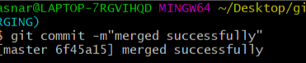

14.Finally delete the ‘js-assignments’ branch.

